Kubernetes Task-07
Task 1: Execute all yaml files shown in video.
Task 2: Taint a Node and Schedule a Tolerant Pod Taint a node with special=true:NoSchedule. Create a pod with a toleration that matches the taint, allowing it to be scheduled on the tainted node.
Task 3: Use NodeSelector to Schedule a Pod on a Specific Node Label a node with env=dev. Create a pod with a nodeSelector that schedules it only on the node labeled env=dev.
Task 4: Use Node Affinity with Soft Scheduling Label a node with env=test. Create a pod with PreferredDuringSchedulingIgnoredDuringExecution node affinity, preferring to schedule it on a node labeled env=test. Remove the label and verify the pod continues to run.
Task 5: Implement Node Affinity with Hard Scheduling Create a pod with RequiredDuringSchedulingIgnoredDuringExecution node affinity, ensuring it will only be scheduled on a node labeled env=prod. Verify the pod cannot be scheduled if no node has the env=prod label.
Task 6: Taint a Node and Use NoExecute with Toleration Seconds Taint a node with special=true:NoExecute. Create a pod with a tolerationSeconds field (e.g., 60 seconds) and observe it gets evicted after 60 seconds on the tainted node.
Kubernetes Task-7 — Complete Step-by-Step Lab
Overall tasks
Task | Topic | Main concept
Task 1 | YAML examples | Tolerations, Equal, Exists, PreferNoSchedule, NodeSelector, Affinity
Task 2 | Taint + Toleration | NoSchedule
Task 3 | NodeSelector | Hard node selection
Task 4 | Node Affinity | Soft preference
Task 5 | Node Affinity | Hard requirement
Task 6 | NoExecute | tolerationSeconds
The document specifically defines Task 2 as applying special=true:NoSchedule and allowing a Pod through a matching toleration.

STEP 0 — Verify your Kubernetes cluster
Run these from your control-plane/master node.
kubectl get nodes -o wide
Then:
kubectl get nodes --show-labels
You should get something similar to:
NAME STATUS ROLES INTERNAL-IP
ip-172-31-29-138 Ready control-plane 172.31.29.138
ip-172-31-17-144 Ready <none> 172.31.17.144
Your exact names may differ.
Important
From this point forward, don't assume the document's:
k8s-worker1
k8s-worker2
are your actual names.
Set variables to make the lab easier.
For example, if your worker is:
ip-172-31-17-144
run:
WORKER1=ip-172-31-17-144
Verify:
echo $WORKER1
If you actually have two workers, set:
WORKER1=<first-worker-name>
WORKER2=<second-worker-name>
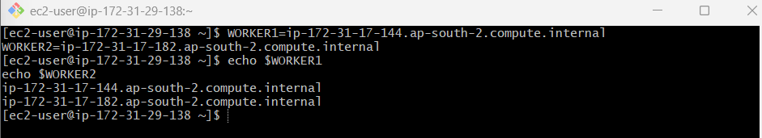
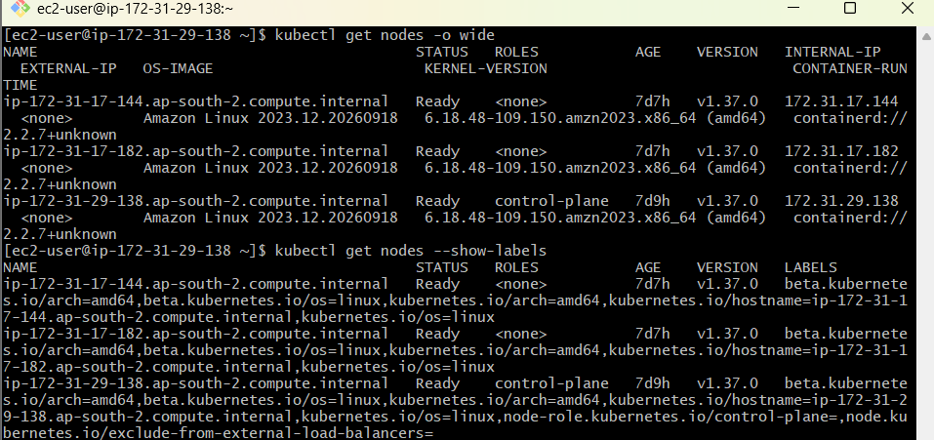

STEP 1 — Check whether nginx image is available
Your document uses:
image: nginx
imagePullPolicy: Never
That means Kubernetes will not pull nginx from Docker Hub. The nginx image must already exist in the node's container runtime.
Check your Pod/container runtime situation.
kubectl get pods -A
If you've already successfully run nginx Pods in your cluster, you're probably okay.
If a Pod later gets:
ImagePullBackOff
or:
ErrImageNeverPull
tell me the output and we'll fix the image issue before continuing.

TASK 1 — Execute the YAML examples
Your document has several examples.
We will do them separately so you understand exactly what each one demonstrates.

TASK 1-A — Toleration using operator: Equal
Step 1 — Apply the taint
Run:
kubectl taint node $WORKER1 special=true:NoSchedule
Expected:
node/... tainted
Verify:
kubectl describe node $WORKER1 | grep -i taint
Expected:
Taints:
special=true:NoSchedule
This is the same special=true:NoSchedule concept demonstrated in your document.
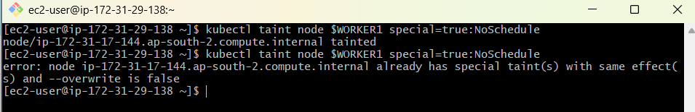

Step 2 — Create YAML
vi firstpod.yaml
Paste:
apiVersion: v1
kind: Pod
metadata:
name: firstpod
spec:
containers:
- name: firstcontainer
image: nginx
imagePullPolicy: Never

tolerations:
- key: "special"
operator: "Equal"
value: "true"
effect: "NoSchedule"
Save:
ESC
:wq
ENTER

Step 3 — Apply
kubectl apply -f firstpod.yaml
Expected:
pod/firstpod created

Step 4 — Check Pod
kubectl get pod firstpod -o wide
Look at:
NODE
You want to see the Pod scheduled on the tainted worker if that node is otherwise suitable.
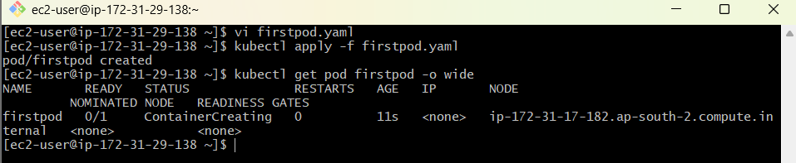

Step 5 — Verify toleration
kubectl describe pod firstpod
Look for:
Tolerations:
special:Equal=true
What did we learn?
Node:
special=true:NoSchedule
Pod:
key=special
operator=Equal
value=true
effect=NoSchedule
Therefore:
special=true
+
special=true
=
MATCH
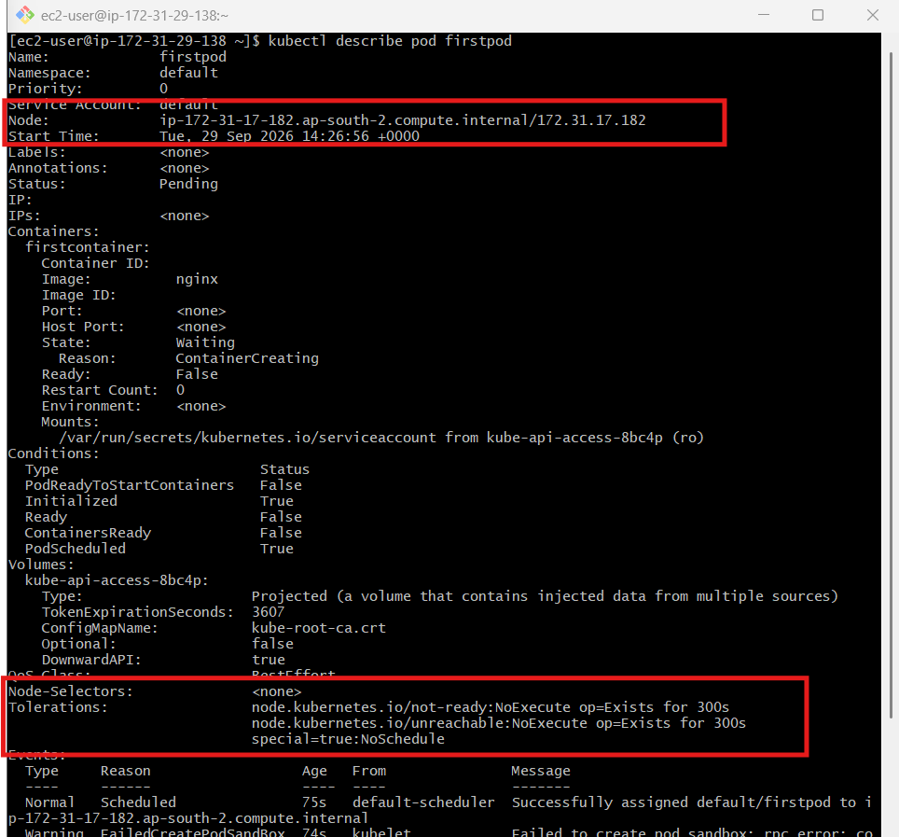

TASK 1-B — PreferNoSchedule
First delete the previous Pod:
kubectl delete pod firstpod
Remove the previous taint:
kubectl taint node $WORKER1 special=true:NoSchedule-
Verify:
kubectl describe node $WORKER1 | grep -i taint
Now apply:
kubectl taint node $WORKER1 special=true:PreferNoSchedule
Verify:
kubectl describe node $WORKER1 | grep -i taint
Expected:
special=true:PreferNoSchedule
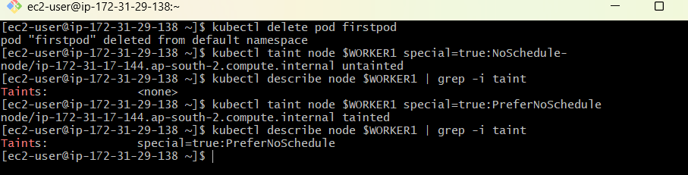

Create Pod
vi firstpod.yaml
Use:
apiVersion: v1
kind: Pod
metadata:
name: firstpod
spec:
containers:
- name: firstcontainer
image: nginx
imagePullPolicy: Never

tolerations:
- key: "special"
operator: "Equal"
value: "true"
effect: "PreferNoSchedule"
Apply:
kubectl apply -f firstpod.yaml
Check:
kubectl get pod firstpod -o wide
Understand PreferNoSchedule
This is a soft restriction.
NoSchedule
↓
Don't schedule unless tolerated

PreferNoSchedule
↓
Try to avoid the node
↓
But scheduling can still happen if necessary
Your document explicitly describes PreferNoSchedule as a soft restriction and contrasts it with NoSchedule.
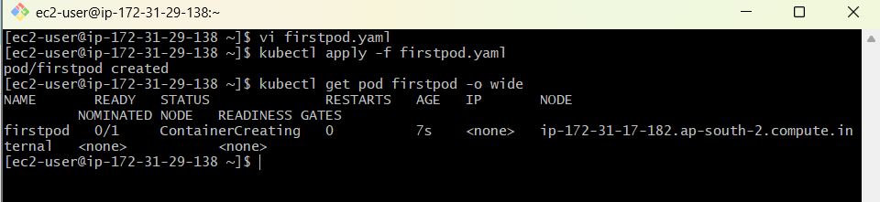

TASK 1-C — Toleration using Exists
Delete Pod:
kubectl delete pod firstpod
Remove previous taint:
kubectl taint node $WORKER1 special=true:PreferNoSchedule-
Apply:
kubectl taint node $WORKER1 special=true:NoSchedule
Now create:
vi firstpod.yaml
Use:
apiVersion: v1
kind: Pod
metadata:
name: firstpod
spec:
containers:
- name: firstcontainer
image: nginx
imagePullPolicy: Never

tolerations:
- key: "special"
operator: "Exists"
effect: "NoSchedule"
Apply:
kubectl apply -f firstpod.yaml
Check:
kubectl get pod firstpod -o wide
Understand Exists
Node:
special=true:NoSchedule
Pod:
key=special
operator=Exists
With Exists, the value is not checked.
So:
special=true
special=abc
special=xyz
can all match the special key.
The document explains this exact distinction: Exists checks the taint key rather than the taint value.
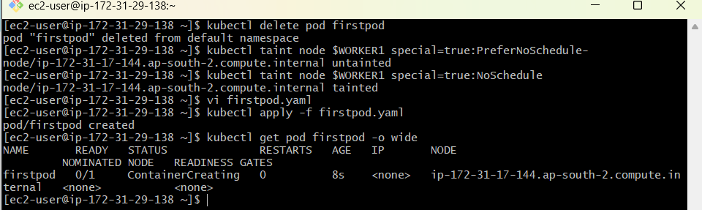

TASK 1-D — NodeSelector
Delete Pod:
kubectl delete pod firstpod
Remove taint:
kubectl taint node $WORKER1 special=true:NoSchedule-
Check labels:
kubectl get nodes --show-labels
Now add:
kubectl label node $WORKER1 env=dev --overwrite
Verify:
kubectl get node $WORKER1 --show-labels
You should find:
env=dev
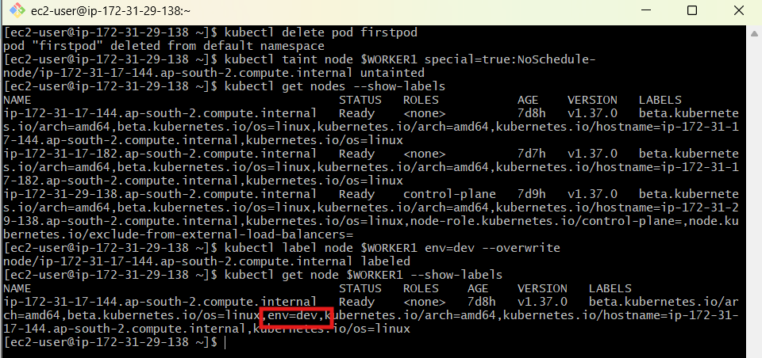

Create Pod
vi firstpod.yaml
Paste:
apiVersion: v1
kind: Pod
metadata:
name: firstpod
spec:
containers:
- name: firstcontainer
image: nginx
imagePullPolicy: Never

nodeSelector:
env: dev
Apply:
kubectl apply -f firstpod.yaml
Check:
kubectl get pod firstpod -o wide
The Pod should be on:
$WORKER1
because that node has:
env=dev
The document describes the same behavior: if no node has the requested env=dev label, the Pod remains Pending.
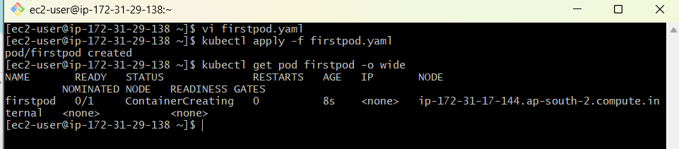

TASK 1-E — Node Affinity — Soft Scheduling
Delete:
kubectl delete pod firstpod
Now we need another node for the preferred scheduling demonstration.
If you have WORKER2:
kubectl label node $WORKER2 env=test --overwrite
Verify:
kubectl get nodes --show-labels
You should have something like:
worker1 env=dev
worker2 env=test
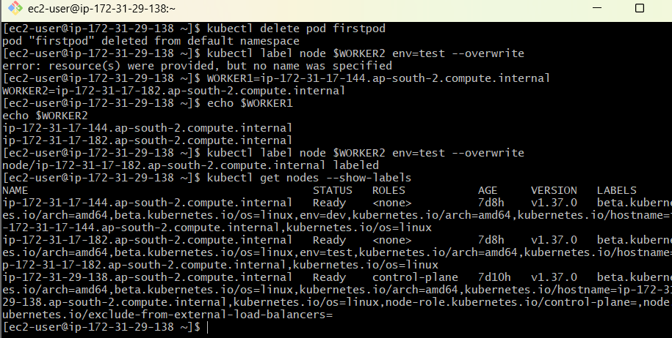

Create YAML
vi firstpod.yaml
Paste:
apiVersion: v1
kind: Pod
metadata:
name: firstpod
spec:
containers:
- name: firstcontainer
image: nginx
imagePullPolicy: Never

affinity:
nodeAffinity:
preferredDuringSchedulingIgnoredDuringExecution:
- weight: 1
preference:
matchExpressions:
- key: env
operator: In
values:
- test
Apply:
kubectl apply -f firstpod.yaml
Check:
kubectl get pod firstpod -o wide
The scheduler prefers the node with:
env=test
This corresponds to the soft-affinity example in the document.
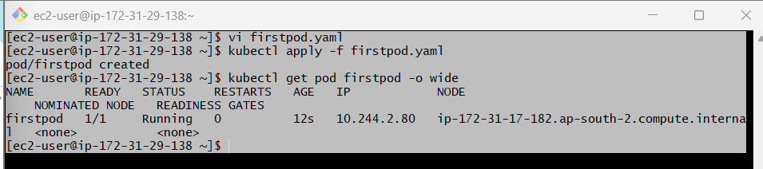

TASK 2 — Taint + Toleration
Now we move to the formal Task 2.
The document's objective is:
special=true:NoSchedule
with a matching Pod toleration.
First clean up:
kubectl delete pod firstpod
Make sure no conflicting taint exists:
kubectl describe node $WORKER1 | grep -i taint
If needed, remove existing special taints:
kubectl taint node $WORKER1 special=true:PreferNoSchedule-
and/or:
kubectl taint node $WORKER1 special=true:NoSchedule-
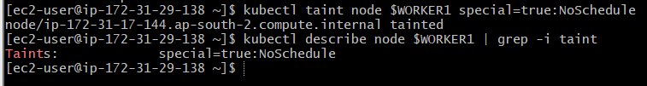
Then apply:
kubectl taint node $WORKER1 special=true:NoSchedule
Verify:
kubectl describe node $WORKER1 | grep -i taint

Create Pod
vi task2-pod.yaml
apiVersion: v1
kind: Pod
metadata:
name: task2-pod
spec:
containers:
- name: nginx
image: nginx
imagePullPolicy: Never

tolerations:
- key: "special"
operator: "Equal"
value: "true"
effect: "NoSchedule"
Apply:
kubectl apply -f task2-pod.yaml
Verify:
kubectl get pod task2-pod -o wide
Then:
kubectl describe pod task2-pod
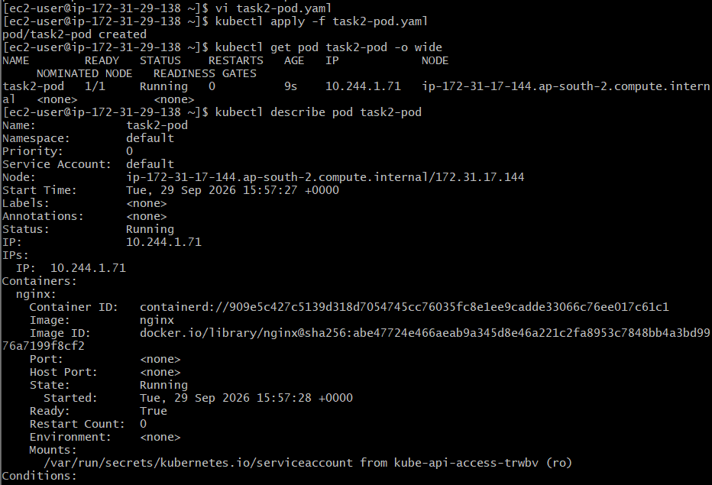

TASK 3 — NodeSelector
First:
kubectl delete pod task2-pod
Remove taint:
kubectl taint node $WORKER1 special=true:NoSchedule-
Label:
kubectl label node $WORKER1 env=dev --overwrite
Verify:
kubectl get nodes --show-labels
Create:
vi task3-pod.yaml
apiVersion: v1
kind: Pod
metadata:
name: task3-pod
spec:
containers:
- name: nginx
image: nginx
imagePullPolicy: Never

nodeSelector:
env: dev
Apply:
kubectl apply -f task3-pod.yaml
Verify:
kubectl get pod task3-pod -o wide
Expected:
STATUS NODE
Running <WORKER1>
The document specifies that without a matching env=dev node, this Pod should remain Pending.
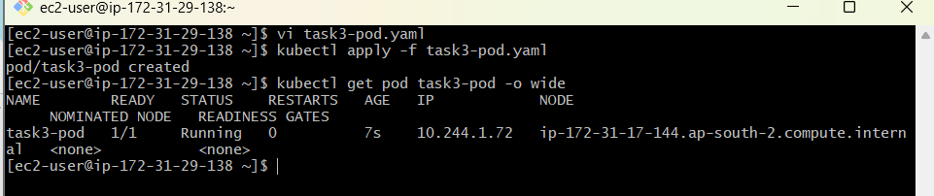

TASK 4 — Soft Node Affinity
Delete:
kubectl delete pod task3-pod
Label the worker:
kubectl label node $WORKER1 env=test --overwrite
Verify:
kubectl get nodes --show-labels
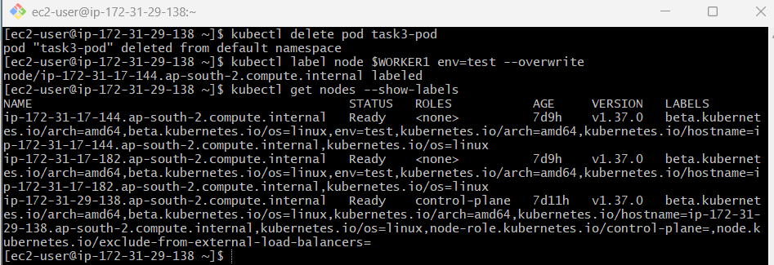

Create YAML
vi task4-pod.yaml
apiVersion: v1
kind: Pod
metadata:
name: task4-pod
spec:
containers:
- name: nginx
image: nginx
imagePullPolicy: Never

affinity:
nodeAffinity:
preferredDuringSchedulingIgnoredDuringExecution:
- weight: 1
preference:
matchExpressions:
- key: env
operator: In
values:
- test
Apply:
kubectl apply -f task4-pod.yaml
Check:
kubectl get pod task4-pod -o wide
It should preferably be scheduled on:
env=test
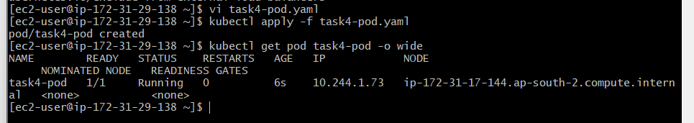

Now remove the label
This is the important part of Task 4.
Run:
kubectl label node $WORKER1 env-
Verify:
kubectl get nodes --show-labels
Now check the Pod:
kubectl get pod task4-pod -o wide
It should continue running.
Why?
Because:
PreferredDuringSchedulingIgnoredDuringExecution
means:
During scheduling
↓
Prefer env=test

After Pod is running
↓
Ignore later label changes
The document specifically requires removing the label and verifying that the already-running Pod continues.
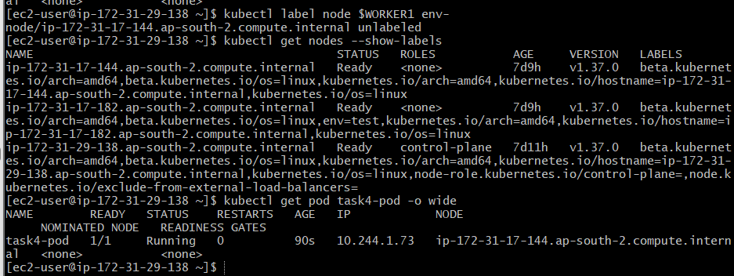

TASK 5 — Hard Node Affinity
Now we test the opposite behavior.
We want:
env=prod
to be a requirement.

Step 1 — Make sure no node has env=prod
kubectl get nodes -l env=prod
Ideally:
No resources found
If your worker still has env=prod, remove it:
kubectl label node $WORKER1 env-
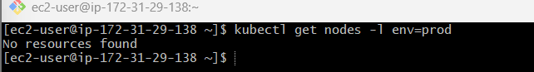

Step 2 — Create YAML
vi task5-pod.yaml
Paste:
apiVersion: v1
kind: Pod
metadata:
name: task5-pod
spec:
containers:
- name: nginx
image: nginx
imagePullPolicy: Never

affinity:
nodeAffinity:
requiredDuringSchedulingIgnoredDuringExecution:
- nodeSelectorTerms:
- matchExpressions:
- key: env
operator: In
values:
- prod

Step 3 — Apply
kubectl apply -f task5-pod.yaml
Check:
kubectl get pod task5-pod -o wide
Expected:
STATUS
Pending
This is correct.
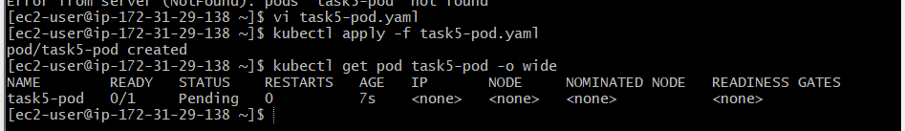

Step 4 — Find out why
kubectl describe pod task5-pod
At the bottom:
Events:
You should see scheduling failure information indicating that no suitable node satisfies the affinity requirement.
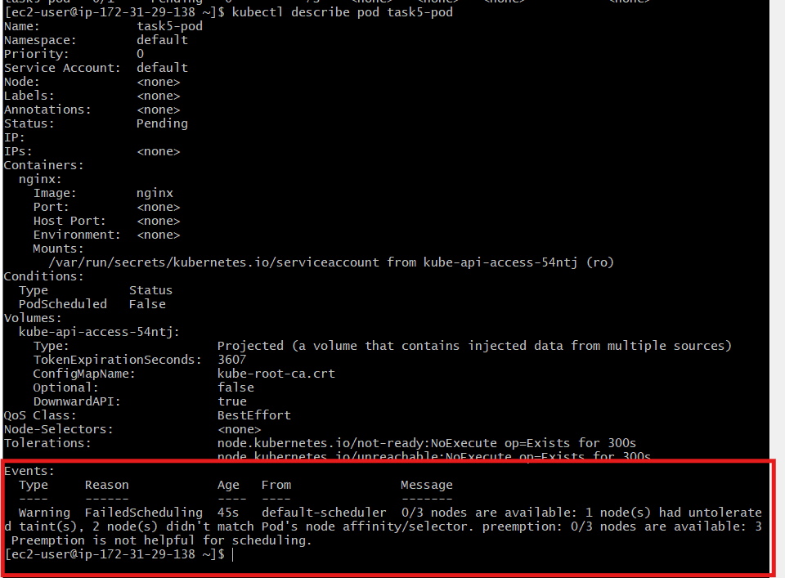

Step 5 — Add env=prod
Now:
kubectl label node $WORKER1 env=prod --overwrite
Verify:
kubectl get nodes --show-labels
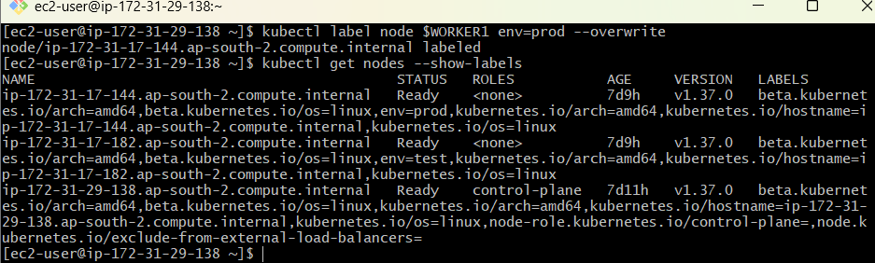

Step 6 — Recreate Pod
The document has you delete and recreate the Pod after adding the required label.
Run:
kubectl delete pod task5-pod
Then:
kubectl apply -f task5-pod.yaml
Check:
kubectl get pod task5-pod -o wide
Now it should become:
Running
on the node with:
env=prod
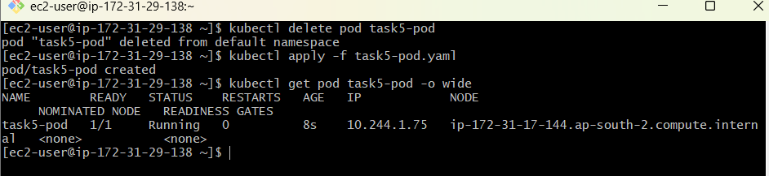
Key difference
Soft:
preferredDuringSchedulingIgnoredDuringExecution
means:
I prefer this node.
Hard:
requiredDuringSchedulingIgnoredDuringExecution
means:
This requirement must be satisfied.

TASK 6 — NoExecute + tolerationSeconds
This is the most important demonstration in this document.
The objective is to use:
special=true:NoExecute
and:
tolerationSeconds: 60
so that the Pod tolerates the taint temporarily and is then evicted if the taint remains.
Important
Do not immediately create the Pod after applying the NoExecute taint.
For the eviction demonstration, the Pod should first be running on the worker, and then we apply the NoExecute taint.

Step 1 — Clean previous Task 5
kubectl delete pod task5-pod
Remove env=prod if you want to leave the cluster clean:
kubectl label node $WORKER1 env-

Step 2 — Create Pod WITHOUT NoExecute taint
Create:
vi task6-pod.yaml
Use:
apiVersion: v1
kind: Pod
metadata:
name: task6-pod
spec:
containers:
- name: nginx
image: nginx
imagePullPolicy: Never
Apply:
kubectl apply -f task6-pod.yaml
Check:
kubectl get pod task6-pod -o wide
We need:
STATUS NODE
Running <WORKER1>
If it runs on another node, tell me before continuing because we need it on $WORKER1.
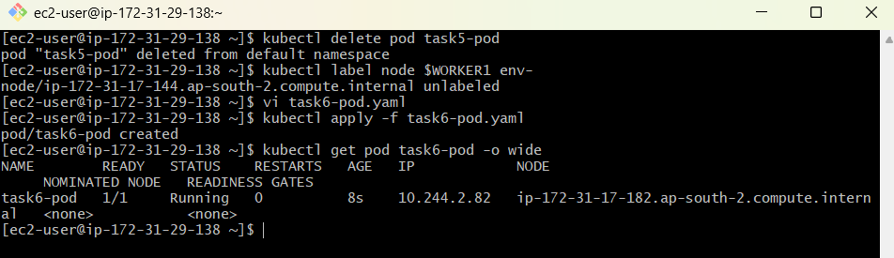

Step 3 — Apply NoExecute taint
Now:
kubectl taint node $WORKER1 special=true:NoExecute
Verify:
kubectl describe node $WORKER1 | grep -i taint
Expected:
special=true:NoExecute

Step 4 — Important observation
Because our current Pod has no toleration, Kubernetes can evict it.
Watch:
kubectl get pod task6-pod -o wide -w
You may see the Pod transition toward termination.
But this is not yet the actual tolerationSeconds: 60 demonstration.
For that, we need the Pod to have the toleration.
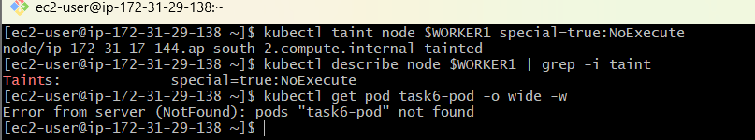

Step 5 — Create Pod with 60-second toleration
First delete:
kubectl delete pod task6-pod
Create:
vi task6-pod.yaml
Paste:
apiVersion: v1
kind: Pod
metadata:
name: task6-pod
spec:
containers:
- name: nginx
image: nginx
imagePullPolicy: Never

tolerations:
- key: "special"
operator: "Equal"
value: "true"
effect: "NoExecute"
tolerationSeconds: 60

Step 6 — Important sequencing
Because the node already has:
special=true:NoExecute
create the Pod:
kubectl apply -f task6-pod.yaml
Check:
kubectl get pod task6-pod -o wide
For the cleanest demonstration, however, I recommend the following sequence:
Remove taint
kubectl taint node $WORKER1 special=true:NoExecute-
Create the Pod
kubectl apply -f task6-pod.yaml
Confirm it is running
kubectl get pod task6-pod -o wide
Expected:
task6-pod 1/1 Running ... <WORKER1>
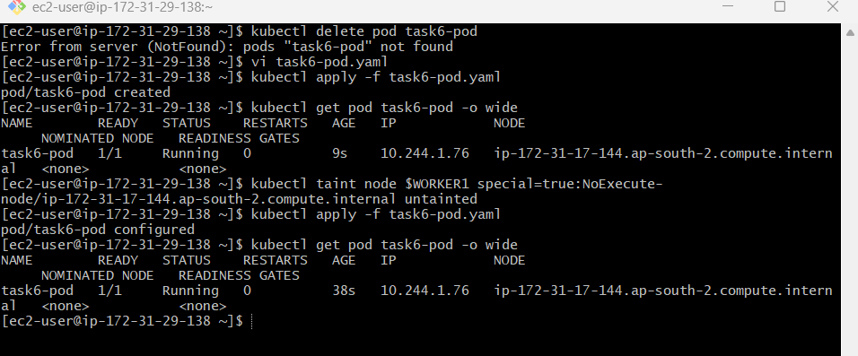
Now apply NoExecute
kubectl taint node $WORKER1 special=true:NoExecute
Immediately watch:
kubectl get pod task6-pod -o wide -w
For approximately 60 seconds, the Pod should remain because:
tolerationSeconds: 60
After the tolerance period expires, Kubernetes can evict the Pod while the taint remains.
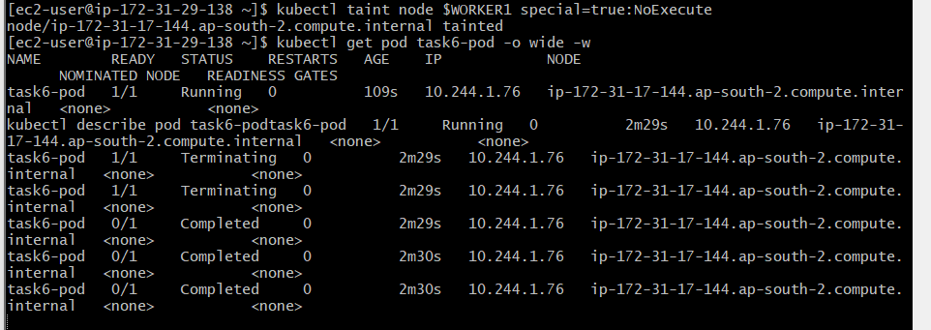

Step 7 — Verify eviction
You can also inspect:
kubectl describe pod task6-pod
and:
kubectl get events --sort-by=.lastTimestamp
Look for eviction/termination-related events.

